RESOURCES FOR ADULTS EXPERIENCING GRIEF FROM THE LOSS OF A BROTHER OR SISTER WITH DISABILITIES

Siblings of people with disabilities benefit from support throughout their lifetime. This need for support continues after a brother or sister has died. The sibling role often shapes one’s identity – siblings can have a powerful impact on their brother or sister with disabilities’ experiences. Siblings often have many roles in their relationship with their brother or sister with disabilities: friend, playmate, advocate, caregiver, and much more. When a brother or sister with disabilities dies, the loss can bring about complex emotions. Currently, there are not enough supports and resources for siblings that experience the loss of their brother or sister with disabilities. The Sibling Leadership Network is working to develop more supports to help with the experience of grief and loss for siblings and we have compiled videos, articles, and websites that we hope will help.
Resources specific to the loss of a sibling with a disability
- Article: Navigating Grief and Loss: A Guide for Siblings of People with IDD by Shruti Tekwani
- Article: Mourning the Loss of a Sibling Rival
- Article: When a Sibling Dies or has a Serious Illness
- Webinar: Sib Grief Webinar by Shruti Tekwani, September 2019
- Website: Sibling Leadership Network Grief and Loss Resources
Grief website resources for family members
- The Hospice Foundation – Grief Resources
- What’s Your Grief? Website
- Compassionate Friends
For additional crisis support:
Crisis Text Line serves anyone, in any type of crisis, providing free access, 24/7.
https://www.crisistextline.org/text-us/ Text HOME to 741741 to reach a Crisis Counselor

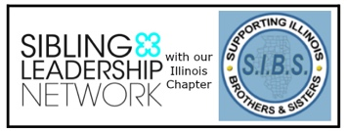  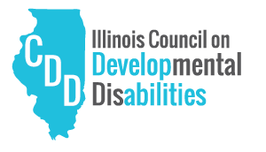 | This resource was developed by the Sibling Leadership Network in partnership with Supporting Illinois Brothers and Sisters with an investment of the Illinois Council on Developmental Disabilities. This project is supported in part by grant number CFDA 93.630 from the U.S. Administration for Community Living, Department of Health and Human Services, Washington, D.C. 20201. Grantees undertaking projects with government sponsorship are encouraged to express freely their findings and conclusions. Points of view or opinions do not, therefore, necessarily represent official ACL policy.

